**NUCLEAR POWER CORPORATION OF**

**INDIA LIMITED**

(A Government of India Enterprise)



KAIGA GENERATING STATION

Vocational Training Report

**(From 17/01/2019 to 31/01/2019)**





Report by: **Pallavi Savant**

USN**:1JS16CS064**

B. E. (3RD year),

Computer Science & Engineering,

**JSS ACADEMY OF TECHNICAL EDUCATION**

**BANGALORE-560060**

**ACKNOWLEDGEMENT**

The completion of this training brings with it a sense of satisfaction, but it is never complete without thanking the people whose constant Support and lead to the successful accomplishment of this training.

This has been possible due to motivation, guidance and support from various people. I would like to individually thank them for their immense help.

I express my sincere gratitude to **Mr. M. Seshaiah**, Training Superintendent, NTC Kaiga for giving me this opportunity to undertake this project work at KGS.

I am grateful to **Mr. M. R. Velayudhan**, SO/G (NTC) ,**Mr. S. Vittal**, SO/F (NTC) and **Mr. K. T. Balakrishnan**, SO/F (NTC) fortheir incredible support and encouragement given to me for theduration of this training.

I also take this opportunity to express my sincere gratitude to **Mr. S. K. Datta,** SO/E (NTC), **Mr. B. T. SundarNayak**, SA/F(NTC) and **Mr. Biplaba M. Acharya,** T/F (NTC) for their extremely helpful guidance during my training period and in the completion of my project.

I would like to thank **Mr. K. S. Lakshmikantha**, SA/F (NTC) for his support.

I also avail this opportunity to express my deep sense of gratitude to my parents for being my never-ending source of support and motivation.

**TABLE OF CONTENTS**

1. **INTRODUCTION**

* India’s Nuclear Power Program
* Kaiga Generating Station
* Principle of energy generation at KGS
* Reactor Components
* Various Types Of computer Based System(CBS)
* Simulator facility

1. **THE PROJECT UNDERTAKEN**

* Project 1: Project Specification.

Description & Implementation

Source code

* Project 2: Project Specification.

Description & Implementation

Source code

* Project 3: Project Specification.

Description & Implementation

Output

Source Code

1. **OTHER STUDIES (IT Infrastructure)**

**INTRODUCTION**

A nuclear reactor uses nuclear fission energy to produce electricity.Fission, caused by the absorption of neutron occurs with certainnuclei of high atomic mass number. When fission takes place,the excited compound nucleus formed after the absorption of aslow moving neutron breaks up into two smaller nuclei calledfission fragments.

Only three nuclides have the stability to permit storage for longtime, namely

Uranium- 233

Uranium-235

Plutonium-239

are fissionable by neutrons of all energies from thermal values(or less) to millions of electron volts. Of the three nuclides onlyUranium-235 is found naturally. The others are produced artificiallyfrom Thorium-232 and Uranium-238 respectively.

The basic nuclear reaction used in a nuclear power plant is givenbelow.



**INDIA’S NUCLEAR POWER PROGRAM**

Nuclear power generation made a beginning in 1960. It has proved itself to be environmental friendly and a viable source of electricitygeneration on a self-reliant basis.

India’s long-term nuclear power program is based on ultimatelytapping of vast indigenous thorium resources for electricitygeneration. India’s uranium resources can support the first stageprogram of about 10,000 MWe of Pressurized Heavy WaterReactors (PHWRs) using natural uranium as fuel and heavywater as moderator and coolant. The second stage aims atincreasing the energy potential of natural uranium to about 3000,000MWe by using Fast Breeder Reactors, which utilize plutonium(obtained from recycled fuel).

India’s 3-stage nuclear program is as mentionedbelow.

STAGE1: 10,000 MW through natural uranium fuelled PHWR’s.

STAGE2: Fast breeder reactors with plutonium as fuel and thoriumas blanket for breeding U-233.

STAGE3: Breeder reactors using U-233 as fuel andthorium as blanket.

A short-term goal is to complement generation of electricityaway from coal mines.

India’s long-term nuclear energy policy is based on recyclingnuclear fuel and harnessing available thorium resource.The energy potential of this 3-stage program is placed to be 20 timesmore than the energy potential of coal reserves.

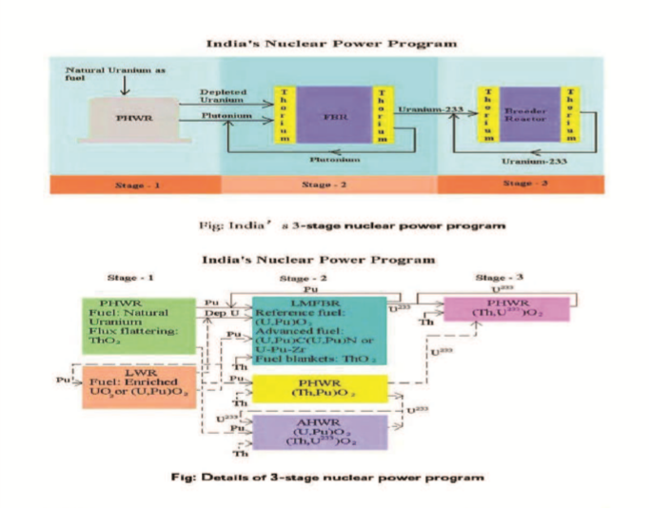

Nuclear Power Corporation of India Limited (NPCIL) is a public sectorEnterprise with an objective of operating Atomic Power Projects forgeneration of electricity in pursuance of schemes and programs ofgovernment of India under Atomic Energy Act.

At present Nuclear Power Corporation have 17 reactors at six locations inoperation. First of these to be built is the Tarapur 1&2 (with 2x160MWecapacity) which is Boiling water reactors (BWRs) and those builtsubsequently are all pressurized Heavy water Reactors (PHWRs) whichare Rajasthan 1,2,3&4 (with 4x220 MWe), Kakrapar 1 & 2 (with 2x220MWe), Narora1 & 2 (with 2x220MWe), Madras (Kalpakkam) 1 &2 (with2x220MWe), Tarapur 3 &4 (with2x500MWe) and Kaiga 1, 2,3&4 (with 4x220MWe).

**KAIGA GENERATING STATION**

Kaiga, once a tiny village located amidst sylvan surrounds of Western Ghats and situated at 12km away on the left bank of river Kali upstream of Kadra dam in Uttar Kannada district of Karnataka, has been transformed into a modern and start-of-the-art nuclear power plant.

Kaiga Generating station (KGS) has 4 operating reactors. Each of these reactors has the capacity to produce 220 MW. All four reactors are PHWRs (Pressurized

Heavy Water Reactor) using natural Uranium as the fuel and Heavy water as the coolant moderator.



# WHY NUCLEAR POWER PLANT AT KAIGA?

Hydroelectric generation is the main source of power in Karnataka. Thehydel power stations, which are all dependent on the monsoon, are mainlyat Kali nadi complex, Supa, Sharawati, Tungabhadra and Krishnasagar.In spite of all these hydel stations, Karnataka faces chronic power storage.To remedy this, state plans to set up many thermal power plants, despitethe difficulties of having coal from long distance. For obtaining an optimalmix of various forms of power generation, it was proposed to set up a baseload nuclear power station at Karnataka. Finally expert committees choseKaiga site after considering the characteristic of numerous othersites in Karnataka, Tamil Nadu, Andhra Pradesh, Kerala and Goa for thesouthern power grid.

# APPROVAL OF SITE

The government of India accorded to set up a nuclear station at Kaigain July 1985 based on the recommendation of site selectioncommittee constituted by the department of atomic energy. The expertcommittee chose this site after taking various factors likepopulation density, agriculture, water availability, and impact onforestland, geological and hydrological factors, and seismic conditions,transportation of heavy/over dimensional components and evacuation ofpower.

The government of India conveyed in June 1987, the administrativeand financial sanction for setting up a nuclear power plant of twounits of 220MWe each of pressurized heavy water reactor. Thesereactors use heavy water as coolant and moderator and natural uranium asfuel with on- line fuelling facilities.

# LAND ACQUISTION FOR 6 UNITS

732 hectares of forestland were released/ earmarked for the total project.Out of which 120 hectares were the 6 units and 612 hectares for thetransmission lines. Out of 40 hectares of land reserved for the units 1 & 2,only 38.9 hectares were used for plants works. 261 hectares of private landwas acquired 171 hectares for the site and 90 hectares for the township.5 hectares of government land was acquired for the site



**PRINCIPLE OF ENERGY GENERATION AT KGS**

In Kaiga 1&2 reactors. Natural uranium is used as fuel and heavy water as moderator and coolant. A220 MWe PHWR Unit basically consists of 306 nos. of horizontal pressure tube assemblies or coolant channels assemblies consisting of Zirconium- niobium coolant tubes housed in independent Zircaloycalandria tubes. These assemblies are housed in stainless steel structure called calandria. Calandria is supported at either ends by massive stainless structures called End shields. Each coolant channel assembly contains 12 Nos. of natural Uranium fuel bundles is transported by heavy water coolant flowing in coolant channel, which transfers the heat to light water contained in secondary side of steam generator to produce steam. The stream is allowed to expand in steam turbines, which drives the generator to produce electricity.

On-line fuelling is the key feature of these reactors, which is carried out by means of two remotely operated fuelling machines one on each of the reactor.



**REACTOR COMPONENTS**

# CALANDRIA

It is the heart of reactor. It is horizontal cylindrical vessel. The diameter of its two ends has been stepped down by welding. The main shell with small shells

using an intermediate flexible annulus plate. The annulus plate accommodates differential thermal expansion between stainless steel calandria vaults. The calandria contains moderator and coolant channel assemblies. Calandria is submerged inside a pool of water in calandria vault. This provides thermal shielding around calandria and cooling for the concrete calandria vault walls, which serves as biological shield.

# COOLANT CHANNELS

The coolant channels assemblies are mounted horizontally and pass through calandria and end shields. Each coolant channel assembly consists of coolant tube, rolled at each end of stainless and fitting. The coolant tube is separated from the moderator by Calandria tube, which is rolled into end shield at both ends. Four coiled springs called Garter springs maintain the gap between the coolant and calandria tubes. The annulus space thus formed is filled with carbon-do-oxide gas, which helps in restricting the rate of corrosion of coolant, and calandria tubes. Separate shut down cooling system is provided to remove reactor decay heart during cold shut down.

# HEAVY WATER AND USES

Heavy water is used both as moderator (140 tonnes) and coolant (100 tonnes). The heavy water (D2O) is identical to the ordinary water (H2O) as far as the chemical properties are concerned, but in physical properties there are minor variation (Boiling point 101.14degree and freezing point 3.82degree centigrade). The DEUTERIUM (D2) in heavy water is an isotope of Hydrogen (H2) having one neutron far less than the ordinary water. This helps in neutron economy. Heavy water exists in extremely small quality (1/2000 parts) in ordinary water and is produce from ordinary water only.

# MODERATOR SYSTEM

Moderator system is a low pressure, low temperature system. The moderator in calandria while slowing down high energy neutrons also function as a heat sink in the unlikely event of loss of primary coolant coincident with failure of emergency core cooling.

The heat generated in the moderator in the calandria is transported to heat exchanges where it is transferred to process water system. The chemical purity and acidity level of moderator are maintained through moderator purification system.

# PRIMARY HEAT TRANSPORT SYSTEM (PHT)

The heat generated in the fuel bundles as a result of Uranium fission is removing by heavy water serving to primary coolant. The coolant transports this next to the four steam generators. The circulation through coolant tubes around the fuel bundles is maintained by four pumps each having capacity of 3560m3/hr. The coolant temperature at inlet and outlet of a reactor are 249degree C and 293.3degree centigrade respectively at a pressure of 87Kg/Cm2. The system pressure is maintained by pressurizing pump usingautomatic feed and bleed principle. Instrument relief valves and suitable regulatory and protection system action limits the system pressure to 93.9 Kg/cm2.

# FUELLING MACHINES

Fuelling machines are at the each end of the coolant channel, working in conjunction have the task of being remotely operated, going to the exact position of one out of 306 channels opening and end shielding and sealing plug. Inserting or receiving fuel bundles while the reactor is operating and channel pressure is around 87Kg/cm2 and temperature 280 degrees centigrade. At full load this machine introduces about eight fuel bundles in one channel per day. On power fuelling is a requirement for the reactor operation to maintain respectively besides maintaining the power level. Bidirectional fueling is required to maintain the symmetry. As a result, coolant also moves through the reactor in both directions thus necessitating two sets of outlet headers.

# FUEL

Fuel for reactor is in the form of bundles of 49.53 cm long and 8.17 cm diameter and each bundle consists of 19 hermetically sealed Zirconium tubes containing compacted and centred pallets of natural Uranium 12 such bundles are located in each fuel channel 56 tonnes of natural uranium is required as initial free load charge. Subsequently only 100kg of fuel/day is adequate to produced power equivalent to that produce by 2500 tonnes of coal in a thermal station. All the fuel required by India is manufactured indigenously.

# REACTOR SHUT DOWN SYSTEM

In the primary heated water recycles (PHWR), the shutdown system is capable of completely terminating reactivity of the core of the reactor. Kaiga Atomic power station is provided with two fast acting shutdown systems primary and secondary. The primary shutdown system, which is the primary means of the rendering the reactor sub critical, has shut off mechanism. Operating with cadmium shut off rods at 14 locations in the Reactor. This system can make the reactor sub critical in less than 2 seconds. The secondary shut-off system using 12 poison injection tubes is a fast acting stand by the primary shut down system. Both fast acting shutdown systems are backed by automatic liquid poison addition system injecting controlled quantities of Boron into moderator after receiving the appropriate signal to ensure guaranteed sub critically of the reactor for prolonged periods. Whenever their poison system is not available, addition of poison under gravity to moderator is incorporated.

# SAFETY RELATED SYSTEMS

Safety related system is geared up to Control the reactor power including shutdown and maintaining sub Criticality. Providing adequate core cooling. Containment and confinement of radioactivity.

# CONTROL ROOM

Operation of the station is controlled from the centralized control room. Control panels provide full information to the engineers regarding the station of the plant so to enable them to operate the plant efficiently and effectively.



# TURBO-GENERATOR

Steam at pressure of 40Kg/Cm2 and temperature at 250 degree centigrade and 0.26% wet supplied to the turbine at inlet through shop valves. The turbine is an impulse reaction type having 5-stage high-pressure rotor and 2x5 stage low-pressure rotors. The sped of turbine is at 3000RPM. The generator has a continuous maximum rating of 237.6Mw (e) and terminal voltage is 16.5kV with power factor of 0.9. Steam is extracted from suitable stages of the turbine to prove for six stages regenerative feed heating stator conductor is water-cooled and rotor is cooled by hydrogen. The generator is coupled directly to turbine. The static excitation system consists of the restore converter, power pack automatic voltage regulator, field breaker, and filed flashing equipment. These are required for fast response time, reliability and also maintenance and free from commutation problems, generally faced in DC excitation.

# COOLING SYSTEMS

Condenser and other process system are once through system for the first two units of Kaiga. Water will be drawn from Kadra dam a part of Kali nadi Hydro Electrical scheme. The water does not come in contact with radioactive fluid.

In order that dams do not pose to safety hazards to the nuclear plant, adequate measure are taken including stability and flood routing studies, while fixing the ground level elevation of the plant building there are not possibility of any release of radioactivity in the river of Kali nadi. Since it will cool only the condenser and associated equipments, which have no direct connection with radioactive process.

# COMPUTER BASED SYSTEMS

Computer Based Systems (CBS) installed and commissioned at KGS--1&2 are used for monitoring, controlling and presenting the process information to the operator at the centralized location i.e. in control room. General requirements of computer based systems of a typical Nuclear Power Plant and the design criteria are listed as follows:

1. Provide enough information regarding the status of the plant variables at centralized location.
2. Alert the control room operator using audio-visual alarm in case of any abnormality.
3. Automatic control of process systems to maintain the plant parameters within the specified limits stipulated in the design.
4. Automatic sequential logic control of various plant equipments such as pumps, valves etc. using Programmable Logic Controllers (PLC).
5. The computer based systems shall be of proven design, fault tolerant and incorporate all the features that are necessary for the safe operation of plant & equipments.
6. Provide the data logging and storage facility for future analysis.
7. Redundant and hot standby systems are provided for the computer based system to have uninterrupted availability of the system.
8. Provision has been made to check the healthiness of critical systems during normal plant operation.

**COMPUTERIZED OPERATOR INFORMATION**

**SYSTEM (COIS)**

Computerized Operator Information System (COIS) is data acquisition and computerized operating information system. COIS acquires analog and contact signals itself and from various Computer Based Systems, processes them according to predefined algorithms and generates alarms & utility displays in various formats. COIS consists of three layered architecture. Layer-1 consists of four numbers of I/O Nodes (ION) based on HIMAGNI CPU. Layer-2 consists of two redundant Servers. Layer-3 consists of Two Alarm Display Node (ADN) and Eleven General Display Node (GDN). I/O Nodes and Servers communicate each other using dual redundant I/O LAN. Servers, ADN and GDN communicate each other using display LAN. I/O Nodes acquires data from field and send to both Servers over I/O LAN.

# ARCHITECTURE OF THE COIS SYSTEM:

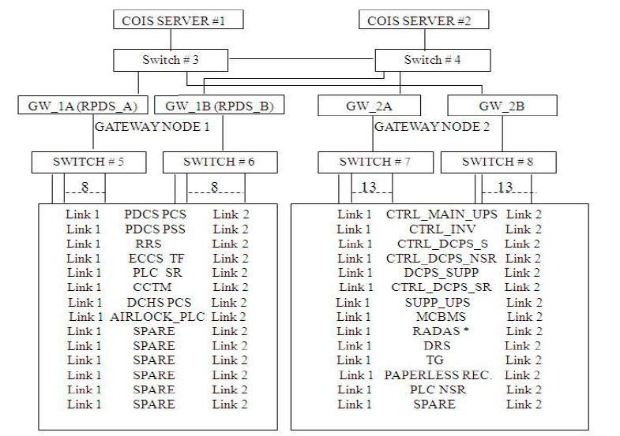

# FUNCTIONS OF COIS:-

1. Scanning of analog-digital systems.
2. Engineering Conversions.
3. Limit checking.
4. Averaging and printing of plant information.
5. ECCS and DNM function.
6. Display and printing of plant information.
7. Printing of logs and reports
8. Archiving and retrieving of historical data.

**COMPUTERISED CHANNEL TEMERATURE MONITORING SYSTEM(CCTMS)**

# INTRODUCTION

Computerised Channel Temperature Monitoring System (CCTMS) monitors the temperature of the coolant (PHT) at the outlet of all 306-coolant channels of the 220 MWe Reactors. By monitoring Channel Outlet Temperature (COT), the system indirectly detects the inadequate coolant flow / abnormal fuel condition in any channel. If the outlet temperature crosses a set limit (299ºC), the system detects it and initiates reactor setback to avoid boiling of coolant. The CCTMS will consist of two installations and each installation will acquire independent inputs (RTDs sensing channel outlet temperature of all coolant channels). The system will acquire the inputs, check for alarms, annunciate alarms, checks for Coincident Very High alarm and generates contact outputs for reactor setback and flux tilt control. The acquired values will be displayed on a local CRT. The raw channel outlet temperature values will also be communicated to Reactor Power Display System (RPDS) for further processing and display in control room.

# PURPOSE

The Hardware Design Description Document has been prepared for Computerised Channel Temperature Monitoring System for KAIGA – 3, 4 / RAPP-5, 6, to meet the standard practices of system hardware configuration. This document aims to provide a clear description of the concepts involved in realization of CCTMS.

# Scope

This document has been prepared as per the procedural requirement outlined in Engineering Procedures for Computer Based Control and Instrumentation Systems, version 0.85 of NPCIL so that it meets AERB safety guidelines for qualifying computer-based system. It describes various functional modules of CCTM system from hardware point of view. The base documents for preparing this HDD is Hardware Requirements Specification (HRS) of CCTMS of Kaiga Atomic Power Project Unit 3&4 and Rajasthan Atomic Power Project Unit 5 & 6, Technical Specification for Computerised Channel Temperature Monitoring System (CCTMS) specification No. PP-E-1842 Rev 1.

# SYSTEM ARCHITECTURE:

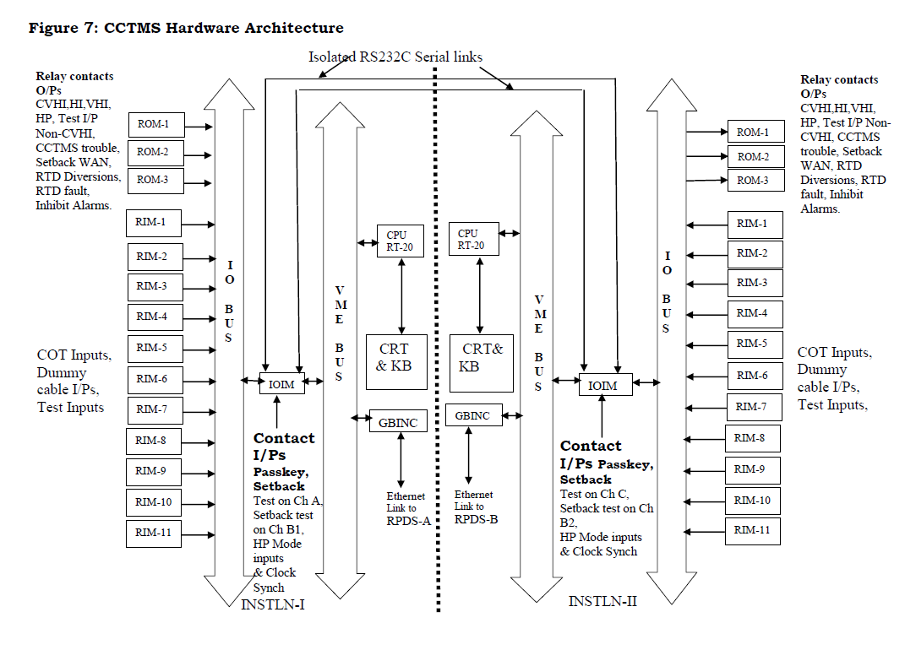

**DUAL COMPUTER HOT STANDBY PROCESS CONTROL SYSTEM**

**(DCHS-PCS)**

# INTRODUCTION

This is User Documentation for Dual Computer Hot Standby-Process Control System(DCHS-PCS). This document gives details of various OIU screens, indications,displays and their interpretation. This document also gives information useful formaintenance of this system.

# SYSTEM DESCRIPTION

Dual computer hot standby-process control system (DCHS-PCS) is a computer basedsystem to provide reliable control to four plant processes. The following processcontrol functions are achieved through DCHS-PCS.

*(1)* Steam Generator Pressure Control (SGPC)

*(2)* Primary Heat Transport (PHT) pressure control.

*(3)* Bleed Condenser (BCD) Pressure Control and

*(4)* Bleed Condenser (BCD) Level control.

Achievement of the automatic process control functions for the above four processeswould include acquisition of measured signals, signal validation, necessary dataprocessing to implement all logics and control algorithms and providing controloutput to final actuator. The necessary process information and diagnostics areprovided to the operator through suitable displays for monitoring purpose.There are three subsystems viz., Control Computer, Display Station and OperatorInformation Console PC referred as Operator Interface Unit-3 (OIU-3). ControlComputers are referred as CC-1 and CC-2. Display Stations are referred as DS-1 /OIU-1 and DS-2 / OIU-2. CCs and OIUs are connected through Dual redundantEthernet LAN. As the name indicates CCs do the control functions and OIUs do theOperator Interface functions the panels and LAN connection diagram of this systemCC-1 and CC-2 are located in 63000-PL-1 in channel room-A and 63000-PL-2 inChannel room-C. OIU-1 and OIU-2 are located in main control panel 6610-PL-4.OIU-3 is located in OIC-PL-3.CC-1 and CC-2 are based on Motorola CPU 68020 and euro bus based I/O cards.OIUs are PC based. OIU-1 and OIU-2 have 6.5-inch monitors with touch screenfacility (no keyboard connected) to view parameters of different processes. OIU-3 iswith 19-inch monitor and keyboard for viewing parameters in various formats,viewing of diagnostic messages and for changing the alterable parameters.

**DUAL COMPUTER HOT STANDBY(DCHS)**

**REACTOR REGULATING SYSTEM(RRS)**

# INTRODUCTION

Dual Computer Hot Standby Reactor Regulating System (DCHS-RRS) is a computer basedcontrol system that provides automatic control of reactor power from 10-6 % FP (FullPower) to 100%FP (Full Power).

The system also provides following facilities:

1. Raises or lowers the reactor power up to the set demand at controlled rates.
2. Provides stable reactor power control as per the demand power at steady state as well as during reactivity transients.
3. Reduces the power on condition like Trip, setback, and 1-1 PCP mode.
4. It compares the Actual Power (AP) signal and the Demand Power (DP) signal to compute Regulating signal (AP-DP). Depending upon this Regulating Signal (RS), it will generate output to drive adjuster rods.
5. Provides interlocks to prevent operator from any increase in reactor demand power during certain conditions and also reduces demand power under certain specified conditions.
6. Provides necessary self-diagnostics to ensure reliable operation of the system.
7. Generates triplicate contact outputs for actuation of Automatic Liquid Poison Addition System (ALPAS).
8. Provides demand power signals to Neutron Power Trip Units (NPTU) of Primary Shutdown System.
9. Provides AP, DP, RS signals to Computerized Operator Information System (COIS) and Digital Recording System (DRS).
10. Computes and displays reactor power values on Main Control Panel. For power values below 10-8 FP, it displays 10-8 FP.

**RADIATION DATA ACQUISITION SYSTEM (RADAS)**

# INTRODUCTION:

Radiation Data Acquisition System (RADAS) is the Data Acquisition and Control

Room Operator Information System for Kaiga Atomic Power Project - 3 & 4. Thissystem processes analog and contact signals from Radiation Monitoring Instrumentsand Heavy Water Leak Detection System Instruments and provides Alarm MessageDisplays and Utility Displays like System Status Table (SST), History, Trend, List ofAnalog and Digital Channels, Mimics and printouts of various displays. All thesedisplays are provided on RADAS Operator’s Interface Units (OIUs) located inControl Room, Technical Support Centre and Health Physicist’s Room.

# CONTEXT DIAGRAM:

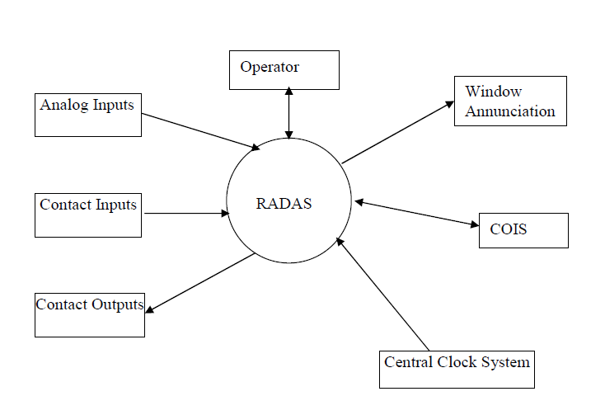

# SYSTEM CONFIGURATION:

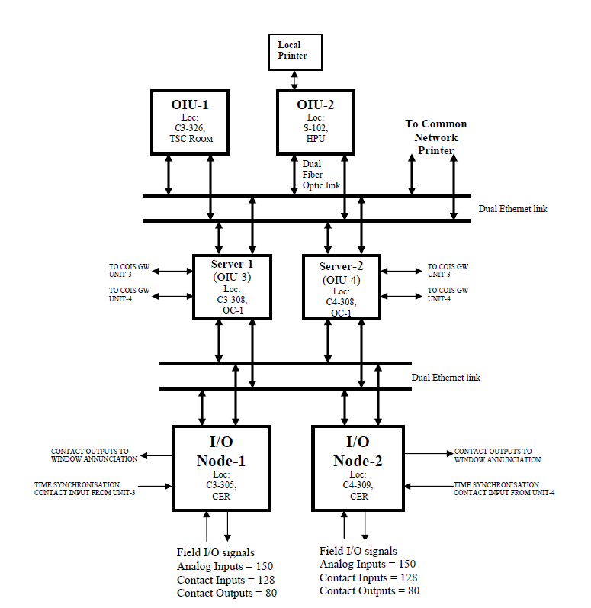

**REACTOR POWER DISPLAY SYSTEM (RPDS)**

# INTRODUCTION & PURPOSE

This document i.e. System Architecture Design (SAD) describes the architectural design of Reactor Power Display System (RPDS) of RAPS 5 & 6 and KAPS 3&4 Projects. This documents describes the partitioning of system in to subsystems. It contains requirements of each subsystem from system point of view and serves the starting point for development lifecycle of RPDS. It defines the functions, which will be carried out by hardware and software.This document is useful for the software developers who require it during software development. Designers and other users of this system can also use this document, for understanding the system Architecture Design of Reactor Power Display System (RPDS). **RAPP-5&6/Kaiga 3&4/66460/SAD, Rev.0, Jan. 06 Page 6 of 22**NPCIL/KAIGA-3,4/RAPP-5,6 RPDS SAD

# SCOPE:

This document is based on Technical Specification for Reactor Power Display System (RPDS) of RAPP 5&6 and Kaiga 3&4 .This document has been prepared as per structural requirements outlined in Engineering Procedures for Computer Based C&I Systems, of NPCIL, so that it meets AERB safety guidelines for qualifying computer-based system. It describes basic architecture used to design the Reactor Power Display System (RPDS).

# FUNCTIONS:

The functions carried out by RPDS are :

1. To acquire inputs from CCTMS & RRS through LAN .
2. To perform engineering conversions and to compute ZMT, ZMTN, ZMTS , ZMTD and generate corresponding alarms. It also checks all BODT values for rationality, and annunciate on monitor and printer if any in alarm state.
3. To provide routine logs and alarms.
4. Maintain a real time clock of RPCS PC Synchronized with the station clock on receiving synchronizing input. Display and print that system has been synchronized with central clock, at the time of synchronization.
5. To provide log of the operation whenever the operator changes a parameter limit value or any other set point on CCTMS or RPDS OR whenever operator changes the password. And also provide log of the operation whenever the operator demands TREND display / printout.
6. To display the data in the correct format as requested by the operator e.g. trend displays
7. To maintain history and transfer the data to tertiary storage like CD as required.
8. To provide for balancing of CCTM system. It is required to do adjustments in the CCTM computer system to compensate for the variations in RTD element resistance, RTD lead resistance, and RTD cable resistance during reactor hot conditioning.

# CONTEXT DIAGRAM:

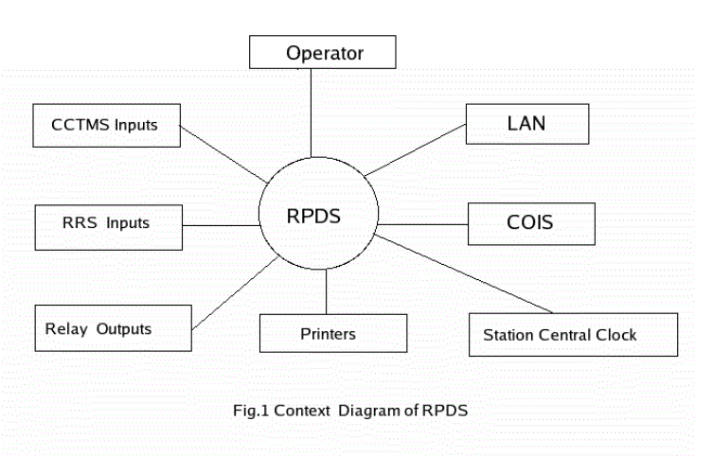

# SYSTEM ARCHITECTURE OF RPDS:

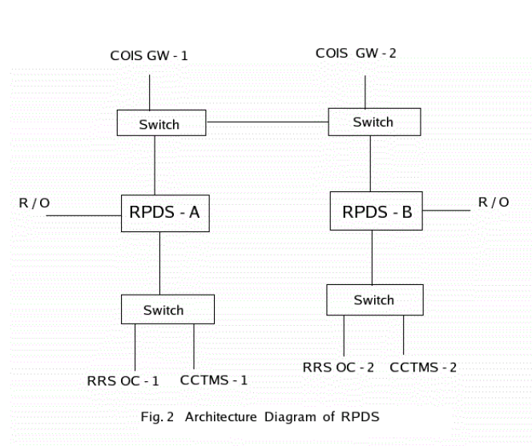

# SIMULATOR FACILITY ATKGS

Following normal operations can be executed**:**

1. Routine testing of reactor protective systems.
2. Isolation/Normalization of electrical equipments.
3. Reactor power raises / lower / set back.
4. Changeover of running equipments such as

I).Primary feed pump.

II).Boiler feed pump.

III).Condensate extraction pumps, etc.

1. Testing of ECCS through COIS
2. Turbine rolling, synchronization of TG and loading.
3. Duty changeover of SG level control valves, hot well level control valves.

8. Testing of atmospheric steam discharge valves and condenser steam dump valves.

9. Operation of shutdown cooling system.

10. Operation of adjustor rods, liquid poison injection systems and shutdown systems (PSS & SSS).

11. Cold reactor start-up.

# Following anticipatory operational occurrences can be created:

1. Reactor setback initiation.
2. Reactor trip and start-up within xenon poison over-ride time.
3. Turbine trip and recovery.
4. TG load rejection and recovery.
5. Class IV power failure and recovery.
6. Reactor trip by secondary shut down system and recovery.
7. Cool down of primary heat transport system.

# Following EOPs can be created:

1. Inadvertent stuck opening of IRV`s.
2. Primary heat transport system feed valves stuck open and bleed valves stuck closed.
3. Moderator system circulation failure.
4. Loss of normal 90% feed water to one steam generator.
5. Feed water control valves to SG remain fully open.
6. Computer based system failure (DPHS, PDCS & COIS).
7. Loss of regulation accident-LORA condition.
8. BCD level control CV full closure
9. Steam dump valve stuck open.
10. Partial flow blockage in coolant channel.

11. Simultaneous failure of class-iii &iv power supply.

12. Failure of moderator system piping at any location.

13. Simultaneous failure of class III and class IV power supplies.

14. Steam discharge valves stuck open.

15. Steam dump valves stuck open.

16. CIES valve stuck open during turbine trip.

# LOCA TYPE EOP`S

1. Large LOCA – RIH or ROH Break

2. Feeder Break (inlet or outlet end of channel)

3. SG Tube Break (double ended rupture)

4. Small LOCA - DNM Tube Break

# More than 500 malfunctions are incorporated at present invarious systems.

1. Signal failure to adjustor rods.
2. Adjustor/shim rods moving in/out.
3. Failure of transmitter output signals to high/low values.
4. Control valves/ Motorized valves failure in any of the following modes. sustain open , sustain close , inhibit open , inhibit close
5. Actuation of electrical protection to generator, transformers and motors.
6. Strainer Choking.
7. Bearing vibration high.
8. Tripping of running pumps and standby pump fail to start

PROJECT 1: CREATE INDEX PAGE FOR MONTHLY REPORT

# PROJECT 1 :SPECIFICATIONS

# PURPOSE:

To study the existing code base of Nuclear traing Centre, Training Effectiveness and Evaluation website. To study how to create webpage which will display all the options available for creating monthly report of nuclear training center.

# **EXISTING SYSTEM**:

There is a existing web page which generates a monthly report of nuclear training centre. There are many stages while creating a monthly report. Firstly we select the month and the year for which the report is to be generated.

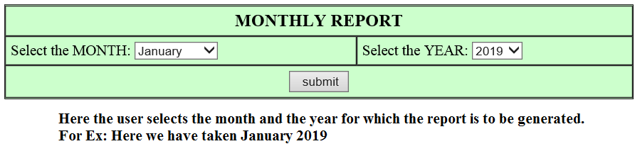

After selection of dates the window turns to the INDEX page where the user has to edit the required contents of the report which are suitable with the JAN 2019. There are many fields which are editable so the user has to be careful while editing the things. The INDEX page contains many hyperlinks which makes the user to edit any of the topics easily. The user can directly click on the links and edit anything from it.These subpages after you clicking on the link display all the contents on the single page making it complicated to edit and update the contents.The below picture shows

# **INDEX PAGE**

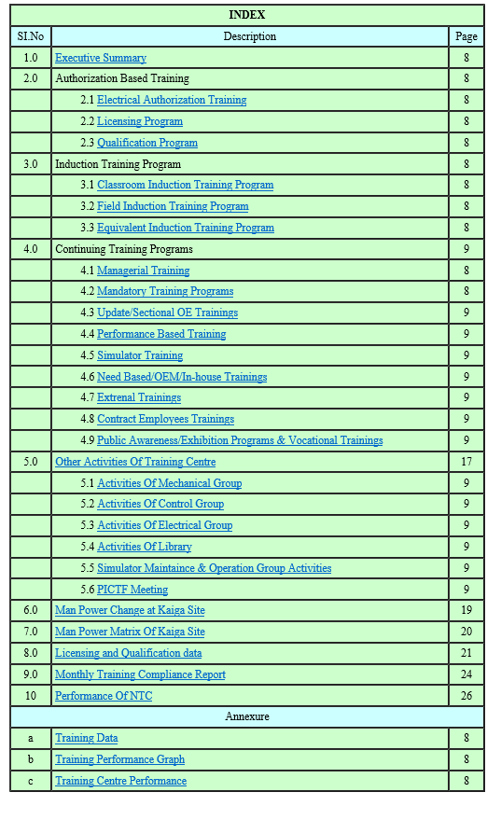

# **PROPOSED SOLUTION:**

The index page contents are provided with drop down box where where you can select your respective options and will take you to next web page which are further given different links linked to respective web pages .The link of the page is given below

http://10.32.2.233/ntc/manpower_matrix/monthly/report_final.cfm

**PROJECT :OUTPUT**

# **PROJECT DESCRIPTION:**

This project will help you to edit the monthly report as well as keep the records of it.

IMPLEMENTATION DETAILS

**FRONT PAGE:**

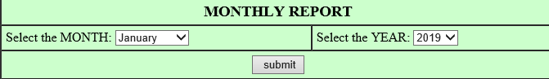

# **INDEX PAGE:**

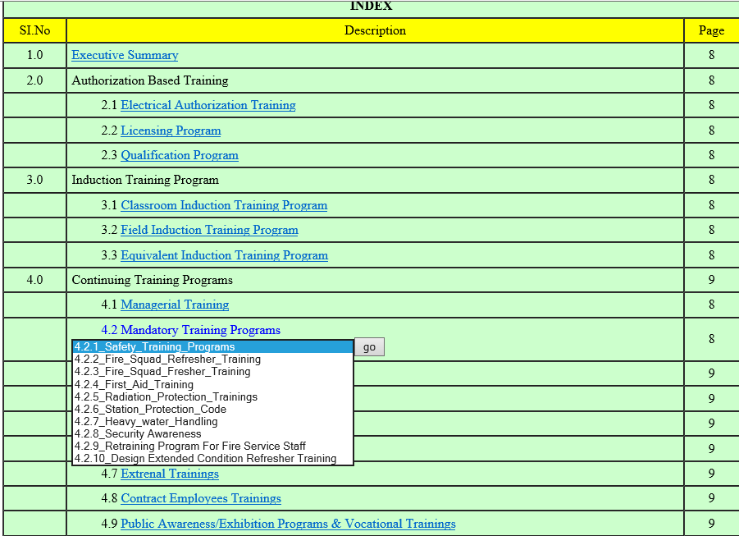

Here in this above index page we have given drop down list for mandatory programs where there were ten subdivisions and previously everything was displayed in single page which made it tedious to read as well as edit it respectively.

### PROJECT 1 :SOURCE CODE

<html>

<body>

<cfset trg="#Trg_NO# - #Trg_NO1#">

<b> You have successfully logged in</b>

<table border="1tp" cellpadding="5" cellspacing="0" align="center" width="900" bgcolor="#CCFFCC" bordercolor="black">

<tr><td colspan=8 align=center><b>INDEX</b></td></tr>

<tr><td align=center bgcolor=yellow>SI.No</td><td align=center bgcolor=yellow>Description</td><td align=center bgcolor=yellow>Page</td></tr>

<tr><td align=center>1.0</td><td ><a href="executive_middle.cfm?dirpath=<cfoutput></cfoutput>">Executive Summary</a></td><td align=center>8</td></tr>

<tr><td align=center>2.0</td><td>Authorization Based Training</td><td align=center>8</td></tr>

<tr><td align=center></td><td>&nbsp&nbsp&nbsp&nbsp&nbsp&nbsp&nbsp&nbsp&nbsp2.1 <a href="2.1_middle.cfm?dirpath=<cfoutput>#trg#</cfoutput>">Electrical Authorization Training</a></td><td align=center>8</td></tr>

<tr><td align=center></td><td>&nbsp&nbsp&nbsp&nbsp&nbsp&nbsp&nbsp&nbsp&nbsp2.2&nbsp<a href="2.2_middle.cfm?dirpath=<cfoutput>#trg#</cfoutput>">Licensing Program</a></td><td align=center>8</td></tr>

<tr><td align=center></td><td>&nbsp&nbsp&nbsp&nbsp&nbsp&nbsp&nbsp&nbsp&nbsp2.3&nbsp<a href="2.3_middle.cfm?dirpath=<cfoutput>#trg#</cfoutput>">Qualification Program</a></td><td align=center>8</td></tr>

<tr><td align=center>3.0</td><td>Induction Training Program</td><td align=center>8</td></tr>

<tr><td align=center></td><td>&nbsp&nbsp&nbsp&nbsp&nbsp&nbsp&nbsp&nbsp&nbsp3.1 <a href="3.1_middle.cfm?dirpath=<cfoutput>#trg#</cfoutput>">Classroom Induction Training Program</a></td><td align=center>8</td></tr>

<tr><td align=center></td><td>&nbsp&nbsp&nbsp&nbsp&nbsp&nbsp&nbsp&nbsp&nbsp3.2 <a href="3.2_middle.cfm?dirpath=<cfoutput>#trg#</cfoutput>">Field Induction Training Program</a></td><td align=center>8</td></tr>

<tr><td align=center></td><td>&nbsp&nbsp&nbsp&nbsp&nbsp&nbsp&nbsp&nbsp&nbsp3.3 <a href="3.3_middle.cfm?dirpath=<cfoutput>#trg#</cfoutput>">Equivalent Induction Training Program</a></td><td align=center>8</td></tr>

<tr><td align=center>4.0</td><td>Continuing Training Programs</td><td align=center>9</td></tr>

<tr><td align=center></td><td>&nbsp&nbsp&nbsp&nbsp&nbsp&nbsp&nbsp&nbsp&nbsp4.1 <a href="4.1_middle.cfm?dirpath=<cfoutput>#trg#</cfoutput>">Managerial Training</a></td><td align=center>8</td></tr>

<tr><td align=center></td><td>&nbsp&nbsp&nbsp&nbsp&nbsp&nbsp&nbsp&nbsp&nbsp<h13 style="color:blue;">4.2 Mandatory Training Programs</h13><BR>

<form name="myform">

<select name="mylist" >

<option value="4.2.1_middle.cfm">4.2.1_Safety_Training_Programs

<option value="4.2.2_middle.cfm"> 4.2.2_Fire_Squad_Refresher_Training

<option value="4.2.3_middle.cfm"> 4.2.3_Fire_Squad_Fresher_Training

<option value="4.2.4_middle.cfm">4.2.4_First_Aid_Training

<option value="4.2.5_middle.cfm"> 4.2.5_Radiation_Protection_Trainings

<option value="4.2.6_middle.cfm"> 4.2.6_Station_Protection_Code

<option value="4.2.7_middle.cfm"> 4.2.7_Heavy_water_Handling

<option value ="4.2.8_middle.cfm" > 4.2.8_Security Awareness

<option value ="4.2.9_middle.cfm" > 4.2.9_Retraining Program For Fire Service Staff

<option value ="4.2.10_middle.cfm" > 4.2.10_Design Extended Condition Refresher Training

<input type="button" value="go" onClick="location.href=myform.mylist.options[myform.mylist.selectedIndex].value">

<NOSCRIPT>

<A HREF="4.2.1_middle.cfm">4.2.1_Safety_Training_Programs</A>

</NOSCRIPT>

</form>

</td>

<td align=center> 8</td>

</tr>

<tr><td align=center></td><td>&nbsp&nbsp&nbsp&nbsp&nbsp&nbsp&nbsp&nbsp&nbsp4.3 <a href="4.3_middle.cfm?dirpath=<cfoutput>#trg#</cfoutput>">Update/Sectional OE Trainings</a></td><td align=center>9</td></tr>

<tr><td align=center></td><td>&nbsp&nbsp&nbsp&nbsp&nbsp&nbsp&nbsp&nbsp&nbsp4.4 <a href="4.4_middle.cfm?dirpath=<cfoutput>#trg#</cfoutput>">Performance Based Training</a></td><td align=center>9</td></tr>

<tr><td align=center></td><td>&nbsp&nbsp&nbsp&nbsp&nbsp&nbsp&nbsp&nbsp&nbsp4.5 <a href="4.5_middle.cfm?dirpath=<cfoutput>#trg#</cfoutput>">Simulator Training</a></td><td align=center>9</td></tr>

<tr><td align=center></td><td>&nbsp&nbsp&nbsp&nbsp&nbsp&nbsp&nbsp&nbsp&nbsp4.6 <a href="4.6_middle.cfm?dirpath=<cfoutput>#trg#</cfoutput>">Need Based/OEM/In-house Trainings</a></td><td align=center>9</td></tr><tr><td align=center></td><td>&nbsp&nbsp&nbsp&nbsp&nbsp&nbsp&nbsp&nbsp&nbsp4.7 <a href="4.7_middle.cfm?dirpath=<cfoutput>#trg#</cfoutput>">Extrenal Trainings</a></td><td align=center>9</td></tr><tr><td align=center></td><td>&nbsp&nbsp&nbsp&nbsp&nbsp&nbsp&nbsp&nbsp&nbsp4.8 <a href="4.8_middle.cfm?dirpath=<cfoutput>#trg#</cfoutput>">Contract Employees Trainings</a></td><td align=center>9</td></tr><tr><td align=center></td><td>&nbsp&nbsp&nbsp&nbsp&nbsp&nbsp&nbsp&nbsp&nbsp4.9 <a href="4.9_middle.cfm?dirpath=<cfoutput>#trg#</cfoutput>">Public Awareness/Exhibition Programs & Vocational Trainings</a></td><td align=center>9</td></tr><tr><td align=center>5.0</td><td><a href="5_middle.cfm">Other Activities Of Training Centre</a></td><td align=center>17</td></tr><tr><td align=center></td><td>&nbsp&nbsp&nbsp&nbsp&nbsp&nbsp&nbsp&nbsp&nbsp5.1 <a href="5.1_middle.cfm?dirpath=<cfoutput>#trg#</cfoutput>">Activities Of Mechanical Group</a></td><td align=center>9</td></tr><tr><td align=center></td><td>&nbsp&nbsp&nbsp&nbsp&nbsp&nbsp&nbsp&nbsp&nbsp5.2 <a href="5.2_middle.cfm?dirpath=<cfoutput>#trg#</cfoutput>">Activities Of Control Group</a></td><td align=center>9</td></tr><tr><td align=center></td><td>&nbsp&nbsp&nbsp&nbsp&nbsp&nbsp&nbsp&nbsp&nbsp5.3 <a href="5.3_middle.cfm?dirpath=<cfoutput>#trg#</cfoutput>">Activities Of Electrical Group</a></td><td align=center>9</td></tr><tr><td align=center></td><td>&nbsp&nbsp&nbsp&nbsp&nbsp&nbsp&nbsp&nbsp&nbsp5.4 <a href="5.4_middle.cfm?dirpath=<cfoutput>#trg#</cfoutput>">Activities Of Library</a></td><td align=center>9</td></tr><tr><td align=center></td><td>&nbsp&nbsp&nbsp&nbsp&nbsp&nbsp&nbsp&nbsp&nbsp5.5 <a href="5.5_middle.cfm?dirpath=<cfoutput>#trg#</cfoutput>">Simulator Maintaince & Operation Group Activities</a></td><td align=center>9</td></tr><tr><td align=center></td><td>&nbsp&nbsp&nbsp&nbsp&nbsp&nbsp&nbsp&nbsp&nbsp5.6 <a href="5.6_middle.cfm?dirpath=<cfoutput>#trg#</cfoutput>">PICTF Meeting</a></td><td align=center>9</td></tr><tr><td align=center>6.0</td><td><a href="http://10.32.2.233/ntc/manpower_matrix/monthly/6_middle.cfm?dirpath=<cfoutput>#trg#</cfoutput>">Man Power Change at Kaiga Site</a></td><td align=center>19</td></tr><tr><td align=center>7.0</td><td><a href="http://10.32.2.232/ntc//pro_matrix/main.cfm">Man Power Matrix Of Kaiga Site</a></td><td align=center>20</td></tr><tr><td align=center>8.0</td><td><a href="http://10.32.2.232/ntc/licqua_matrix/licencing.cfm">Licensing and Qualification data</a></td><td align=center>21</td></tr><tr><td align=center>9.0</td><td><a href="http://10.32.2.233/ntc/manpower_matrix/monthly/9_middle.cfm">Monthly Training Compliance Report</a></td><td align=center>24</td></tr><tr><td align=center>10</td><td><a href="http://10.32.2.233/ntc/manpower_matrix/monthly/10_middle.cfm">Performance Of NTC</a></td><td align=center>26</td></tr><tr><td colspan=8 align=center bgcolor=yellow>Annexure</td></tr><tr><td align=center>a</td><td><a href="">Training Data</a></td><td align=center>8</td></tr><tr><td align=center>b</td><td><a href="">Training Performance Graph</a></td><td align=center>8</td></tr><tr><td align=center>c</td><td><a href="">Training Centre Performance</a></td><td align=center>8</td></tr

</table>

<cfdirectory action = "create"

directory= "c:\inetpub\wwwroot\ntc\manpower_matrix\monthly\#trg#"

><a href="new.cfm?dirpath=<cfoutput>#trg#</cfoutput>">click here</a>

</body>

</html>

PROJECT 2 :CREATE WEB PAGE FOR SUB DIVISION OF THE TOPICS

# PROJECT 2 :SPECIFICATIONS

# PURPOSE:

To study the existing code base of Nuclear traing Centre, Training Effectiveness and Evaluation website. To study how to create a webpage for editing and uploading the monthly report of nuclear training center .

# EXISTING SYSTEM:

The current system is not software based system/automated system. It requires the person responsible for the report to type everything from scratch. It s tedious process as the report is long and repetitive process. This process is monotonous and can lead to many errors.

PROPOSED SOLUTION:

We have created a page which gives a monthly report. This website relegates all the monotonous, tedious and time consuming work which was required to create the report in the existing system. Here the user needs to select the specific headings from the index displayed on the web page and fill in the blank spaces. When he clicks submit, automatically a report keeps generating in the back end. Finally when he views the report for review he gets the report in the structure he desires. The proposed system is fast and efficient. The show stopper of the system is its time efficiency and accuracy.

The following link will allow you to access this project

<http://10.32.2.233/ntc/manpower_matrix/monthly/front_final.cfm>

# PROJECT :INDEX PAGE

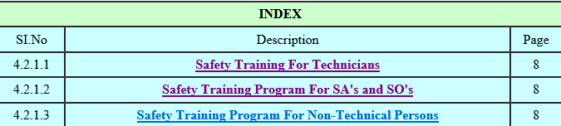

# PROJECT 2 : PROCEDURE

After clicking on the first link (Safety Training For Technicians), a field will open which has the contents of safety training for technicians. There are some text boxes which changes for every month so these fields are editable.

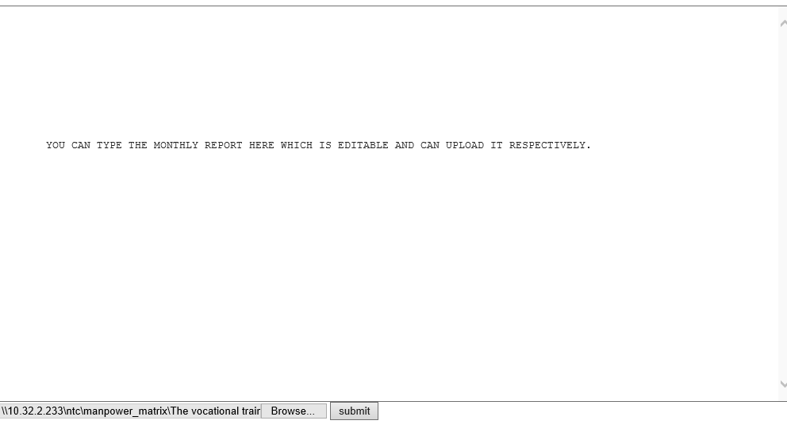

Now you can fill the text box to create monthly report as well as upload a picture by browsing it respectively and submit the contents by clicking the submit button provided.You can browse the picture you want to upload .It will display you the contents you have edited and display you the following page

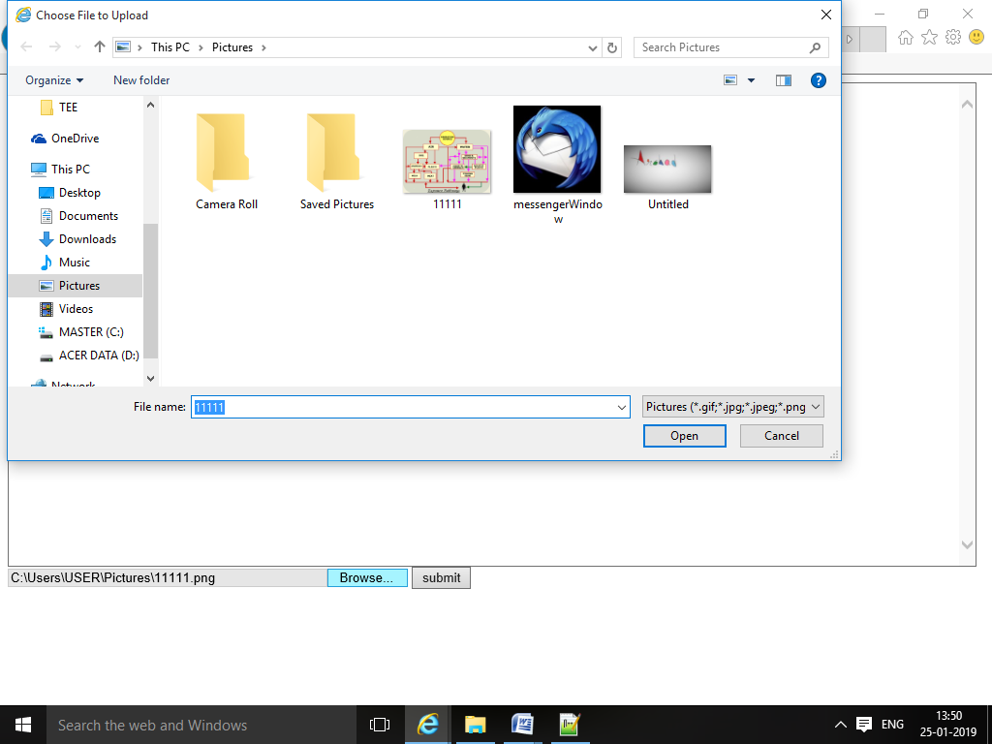

# CODE FOR THE PAGE:

FRONT PAGE CODE:http://10.32.2.233/ntc/manpower_matrix/monthly/4.2.1.1_middle.cfm

<html>

<style>

.abc{

height:500px;

width:1000px;

}

</style>

<body>

<cfset aa=""/>

<cfif FileExists("c:\inetpub\wwwroot\ntc\manpower_matrix\monthly\41.txt")>

<cffile action="read" file="c:\inetpub\wwwroot\ntc\manpower_matrix\monthly\41.txt" variable="aa">

<cfelse>

<cfoutput>#aa#</cfoutput>

</cfif>

<cfform name=llll action="4.2.1.1_back.cfm" method=post enctype="multipart/form-data">

<cfinput type="hidden" name="a">

<cftextarea name="j" value="

#aa# " class="abc"/>

<cfinput type="file" name="file" size="50">

<cfinput type="submit" value="submit" name="jjj"/>

</cfform>

</body>

</html>

CODE FOR THE BACK END: http://10.32.2.233/ntc/manpower_matrix/monthly/4.2.1.1_back.cfm

# PROJECT 2 :CREATE A LOGIN PAGE FOR ACCESS TO THE MONTHLY REPORT SUBMISSION

# LOGIN PAGE:

This is the login page to monthly report of nuclear training center where the CCNO of the employee is to be checked .If you login with the valid ccno will direct you to the page <http://10.32.2.233/ntc/manpower_matrix/monthly/front_r.cfm>

<html>

<body>

<cfoutput >

<b>#j# </b>

</cfoutput>

<cffile action="write" file= "c:\inetpub\wwwroot\ntc\manpower_matrix\monthly\#a#\41.txt" output=#j# addNewLine = "Yes">

<cffile action="upload" destination="c:\inetpub\wwwroot\ntc\manpower_matrix\monthly\uploaded_images" fileField="form.file" nameConflict = "Overwrite"

>

<cfset Uploaded_File_Name = CFFile.ClientFile>

<CFOUTPUT>File: [#Uploaded_File_Name#]</CFOUTPUT>

<CFSET file_ext = ListGetAt(Uploaded_File_Name, 2, ".")>

<cfoutput>#file_ext#</cfoutput>

<cfset sour="c:\inetpub\wwwroot\ntc\manpower_matrix\monthly\uploaded_images\" & #Uploaded_File_Name#>

<cfset dest="c:\inetpub\wwwroot\ntc\manpower_matrix\monthly\uploaded_images\" & "41" &"."&#file_ext#>

<cffile action = "rename"

source =#sour#

destination=#dest#>

<p> Successfully Uploaded </p>

</body>

<html>

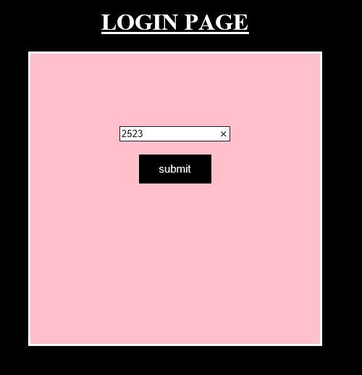

CODE FOR LOGIN PAGE http://10.32.2.233/ntc/manpower_matrix/monthly/login.cfm

<html>

<body style="background-color:black;">

<head>

<style>

.button{

background-color:black;

border:1px solid black;

color:white;

display:inline-block;

font-size:15px;

height:40px;

width:100px;

}

.abc{

background-color:pink;

border:3px solid white;

height:200px;

width:200px;

align:center;

padding: 100px 100px;

}

.pal{

padding:100px 100px;

color:white;

size:20px;

}

</style>

</head>

<div class="pal" align=center>

<h1><u> LOGIN PAGE</u> </h1>

<div class="abc" align=center>

<cfform

name=login action="http:\\10.32.2.233\ntc\manpower_matrix\monthly\front_r.cfm" method=post >

<cfinput type="text" name="CCNO" value="ccno" ></br></br>

<cfinput type="button" name="submit" value="submit" class="button">

</cfform>

</div>

</div>

</body>

</html>

PROJECT 3 : GET ALL THE CONTENT AT SEPERATE FOLDER MONTHLY WISE

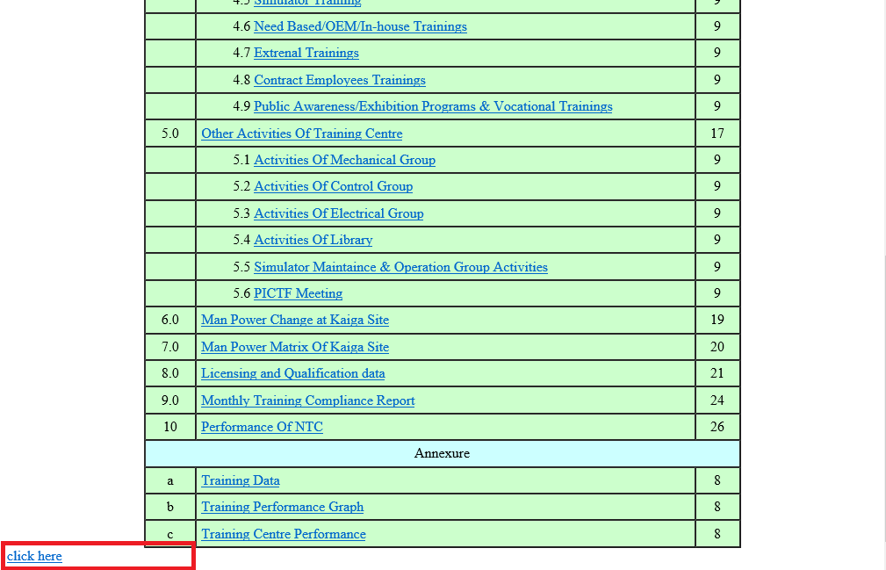

# PROCEDURE:

On clicking click here the folder will be created of respective month for which you are preparing report for .Inside that folder html file will be created which is editable.

# CODE FOR THE PAGE : <http://10.32.2.233/ntc/manpower_matrix/monthly/new.cfm>

<html>

<body>

<cfset aa=""/>

<cfif FileExists("c:\inetpub\wwwroot\ntc\manpower_matrix\monthly\42.txt")>

<cffile action = "read"

file ="c:\inetpub\wwwroot\ntc\manpower_matrix\monthly\44.txt"

variable = "a">

<cffile action = "append"

file = "c:\inetpub\wwwroot\ntc\manpower_matrix\monthly\#dirpath#\#dirpath#.html"

output = "#a#"

addNewLine = "Yes">

<cfelse>

<cfoutput>#aa#</cfoutput>

</cfif>

<br>

<cfif FileExists("c:\inetpub\wwwroot\ntc\manpower_matrix\monthly\41.txt")>

<cffile action = "read"

file ="c:\inetpub\wwwroot\ntc\manpower_matrix\monthly\41.txt"

variable = "b">

<cffile action = "append"

file = "c:\inetpub\wwwroot\ntc\manpower_matrix\monthly\#dirpath#\#dirpath#.html"

output = "#b#"

addNewLine = "Yes">

<cfelse>

</cfif>

<br>

<cfif FileExists("c:\inetpub\wwwroot\ntc\manpower_matrix\monthly\43.txt")>

<cffile action = "read"

file ="c:\inetpub\wwwroot\ntc\manpower_matrix\monthly\43.txt"

variable = "c">

<cffile action = "append"

file = "c:\inetpub\wwwroot\ntc\manpower_matrix\monthly\#dirpath#\#dirpath#.html"

output = "#c#"

addNewLine = "Yes">

<cfelse>

</cfif>

<br>

<cfif FileExists("c:\inetpub\wwwroot\ntc\manpower_matrix\monthly\44.txt")>

<cffile action = "read"

file ="c:\inetpub\wwwroot\ntc\manpower_matrix\monthly\44.txt"

variable = "d">

<cffile action = "append"

file = "c:\inetpub\wwwroot\ntc\manpower_matrix\monthly\#dirpath#\#dirpath#.html"

output = "#d#"

addNewLine = "Yes">

<cfelse>

</cfif>

<br>

<cfif FileExists("c:\inetpub\wwwroot\ntc\manpower_matrix\monthly\45.txt")>

<cffile action = "read"

file ="c:\inetpub\wwwroot\ntc\manpower_matrix\monthly\45.txt"

variable = "e">

<cffile action = "append"

file = "c:\inetpub\wwwroot\ntc\manpower_matrix\monthly\#dirpath#\#dirpath#.html"

output = "#e#"

addNewLine = "Yes">

<cfelse>

</cfif>

<br>

<cfif FileExists("c:\inetpub\wwwroot\ntc\manpower_matrix\monthly\46.txt")>

<cffile action = "read"

file ="c:\inetpub\wwwroot\ntc\manpower_matrix\monthly\46.txt"

variable = "f">

<cffile action = "append"

file = "c:\inetpub\wwwroot\ntc\manpower_matrix\monthly\#dirpath#\#dirpath#.html"

output = "#f#"

addNewLine = "Yes">

<cfelse>

</cfif>

<br>

<cfif FileExists("c:\inetpub\wwwroot\ntc\manpower_matrix\monthly\47.txt")>

<cffile action = "read"

file ="c:\inetpub\wwwroot\ntc\manpower_matrix\monthly\47.txt"

variable = "g">

<cffile action = "append"

file = "c:\inetpub\wwwroot\ntc\manpower_matrix\monthly\#dirpath#\#dirpath#.html"

output = "#g#"

addNewLine = "Yes">

<cfelse>

</cfif>

<br>

<cfif FileExists("c:\inetpub\wwwroot\ntc\manpower_matrix\monthly\48.txt")>

<cffile action = "read"

file ="c:\inetpub\wwwroot\ntc\manpower_matrix\monthly\48.txt"

variable = "h">

<cffile action = "append"

file = "c:\inetpub\wwwroot\ntc\manpower_matrix\monthly\#dirpath#\#dirpath#.html"

output = "#h#"

addNewLine = "Yes">

<cfelse>

</cfif>

<br>

<cfif FileExists("c:\inetpub\wwwroot\ntc\manpower_matrix\monthly\49.txt")>

<cffile action = "read"

file ="c:\inetpub\wwwroot\ntc\manpower_matrix\monthly\49.txt"

variable = "i">

<cffile action = "append"

file = "c:\inetpub\wwwroot\ntc\manpower_matrix\monthly\#dirpath#\#dirpath#.html"

output = "#i#"

addNewLine = "Yes">

<cfelse>

</cfif>

<br>

<cfif FileExists("c:\inetpub\wwwroot\ntc\manpower_matrix\monthly\50.txt")>

<cffile action = "read"

file ="c:\inetpub\wwwroot\ntc\manpower_matrix\monthly\50.txt"

variable = "j">

<cffile action = "append"

file = "c:\inetpub\wwwroot\ntc\manpower_matrix\monthly\#dirpath#\#dirpath#.html"

output = "#j#"

addNewLine = "Yes">

<cfelse>

</cfif>

<br>

<cfif FileExists("c:\inetpub\wwwroot\ntc\manpower_matrix\monthly\51.txt")>

<cffile action = "read"

file ="c:\inetpub\wwwroot\ntc\manpower_matrix\monthly\51.txt"

variable = "k">

<cffile action = "append"

file = "c:\inetpub\wwwroot\ntc\manpower_matrix\monthly\#dirpath#\#dirpath#.html"

output = "#k#"

addNewLine = "Yes">

<cfelse>

</cfif>

<br>

<cfif FileExists("c:\inetpub\wwwroot\ntc\manpower_matrix\monthly\52.txt")>

<cffile action = "read"

file ="c:\inetpub\wwwroot\ntc\manpower_matrix\monthly\52.txt"

variable = "l">

<cffile action = "append"

file = "c:\inetpub\wwwroot\ntc\manpower_matrix\monthly\#dirpath#\#dirpath#.html"

output = "#l#"

addNewLine = "Yes">

<cfelse>

</cfif>

<br>

<cfif FileExists("c:\inetpub\wwwroot\ntc\manpower_matrix\monthly\53.txt")>

<cffile action = "read"

file ="c:\inetpub\wwwroot\ntc\manpower_matrix\monthly\53.txt"

variable = "m">

<cffile action = "append"

file = "c:\inetpub\wwwroot\ntc\manpower_matrix\monthly\#dirpath#\#dirpath#.html"

output = "#m#"

addNewLine = "Yes">

<cfelse>

</cfif>

<br>

<cfif FileExists("c:\inetpub\wwwroot\ntc\manpower_matrix\monthly\54.txt")>

<cffile action = "read"

file ="c:\inetpub\wwwroot\ntc\manpower_matrix\monthly\54.txt"

variable = "n">

<cffile action = "append"

file = "c:\inetpub\wwwroot\ntc\manpower_matrix\monthly\#dirpath#\#dirpath#.html"

output = "#n#"

addNewLine = "Yes">

<cfelse>

</cfif>

<br>

<cfif FileExists("c:\inetpub\wwwroot\ntc\manpower_matrix\monthly\55.txt")>

<cffile action = "read"

file ="c:\inetpub\wwwroot\ntc\manpower_matrix\monthly\55.txt"

variable = "o">

<cffile action = "append"

file = "c:\inetpub\wwwroot\ntc\manpower_matrix\monthly\#dirpath#\#dirpath#.html"

output = "#o#"

addNewLine = "Yes">

<cfelse>

</cfif>

<br>

<!---<cffile action = "read"

file ="c:\inetpub\wwwroot\ntc\manpower_matrix\monthly\#dirpath#\49.txt"

variable = "p">

<cffile action = "append"

file = "c:\inetpub\wwwroot\ntc\manpower_matrix\monthly\#dirpath#\final_report.html"

output = "#p#"

addNewLine = "Yes">

<br>

<cffile action = "read"

file ="c:\inetpub\wwwroot\ntc\manpower_matrix\monthly\#dirpath#\51.txt"

variable = "q">

<cffile action = "append"

file = "c:\inetpub\wwwroot\ntc\manpower_matrix\monthly\#dirpath#\final_report.html"

output = "#q#"

addNewLine = "Yes">

<br>

<cffile action = "read"

file ="c:\inetpub\wwwroot\ntc\manpower_matrix\monthly\#dirpath#\52.txt"

variable = "r">

<cffile action = "append"

file = "c:\inetpub\wwwroot\ntc\manpower_matrix\monthly\#dirpath#\final_report.html"

output = "#r#"

addNewLine = "Yes">

<br>

<cffile action = "read"

file ="c:\inetpub\wwwroot\ntc\manpower_matrix\monthly\#dirpath#\53.txt"

variable = "s">

<cffile action = "append"

file = "c:\inetpub\wwwroot\ntc\manpower_matrix\monthly\#dirpath#\final_report.html"

output = "#s#"

addNewLine = "Yes">

<br>

<cffile action = "read"

file ="c:\inetpub\wwwroot\ntc\manpower_matrix\monthly\#dirpath#\54.txt"

variable = "t">

<cffile action = "append"

file = "c:\inetpub\wwwroot\ntc\manpower_matrix\monthly\#dirpath#\final_report.html"

output = "#t#"

addNewLine = "Yes">

<br>

<cffile action = "read"

file ="c:\inetpub\wwwroot\ntc\manpower_matrix\monthly\#dirpath#\55.txt"

variable = "u">

<cffile action = "append"

file = "c:\inetpub\wwwroot\ntc\manpower_matrix\monthly\#dirpath#\final_report.html"

output = "#u#"

addNewLine = "Yes">

<br>

<cffile action = "read"

file ="c:\inetpub\wwwroot\ntc\manpower_matrix\monthly\#dirpath#\56.txt"

variable = "v">

<cffile action = "append"

file = "c:\inetpub\wwwroot\ntc\manpower_matrix\monthly\#dirpath#\final_report.html"

output = "#v#"

addNewLine = "Yes">

--->

</body>

</html>